Tutorial 4 Stacks and Queues
Week of 16/2/09

- The following two classes are available to you. The Stack class implements a stack ADT, while the Queue class implements a queue ADT.

class Stack<E> {
// Data members are private and are not shown

public boolean isEmpty() { ... }
public int size() { ... }
public void push{E item) { ... }
public E pop() { ... }
public E peek() { ... }
}

class Queue<E> {
// Data members are private and are not shown

public boolean isEmpty() { ... }
public int size() { ... }
public void enqueue(E item) { ... }
public E dequeue() { ... }
public E getFront() { ... }
}

Draw diagrams representing the contents of stack s1, stack s2 and queue q at the end of the following program:

Queue<Integer> q = new Queue<Integer>();
Stack<Integer> s1 = new Stack<Integer>();
Stack<Integer> s2 = new Stack<Integer>();

s1.push(new Integer(3));
s1.push(new Integer(2));
s1.push(new Integer(1));

while(!s1.isEmpty()) {
s2.push(s1.pop());
if(!s1.isEmpty()) s2.push(s1.peek());
q.enqueue(s2.peek());
}

s1.push(q.dequeue());

Answer:
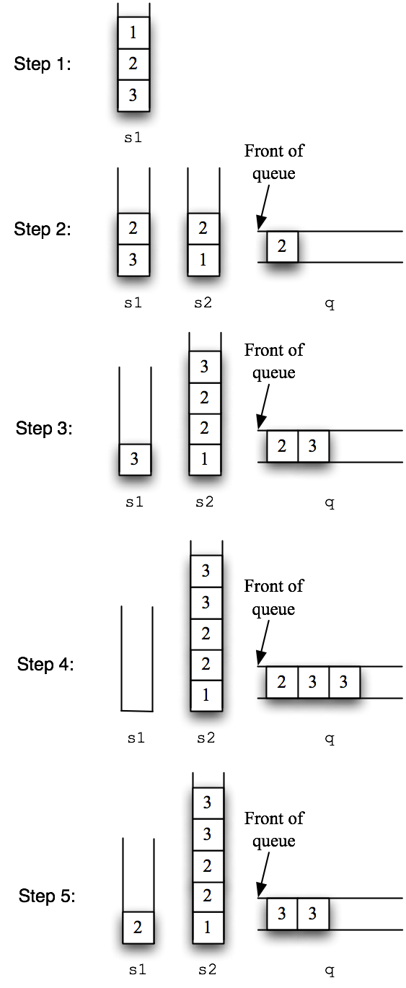

- Given a 2D array of integers (data) with m rows and n columns, explain how you would check whether there is a path of adjacent 1’s from the first element (data[0][0]) to the last element (data[m-1][n-1]). We consider two 1’s to be adjacent if they are next to each other in the same column or in the same row. You should use stack(s) in your solution. If a path exists, you should also explain how to output the path.

Hint: You will need to use one stack for storing the path that has been traced so far and a list to store the visited element.
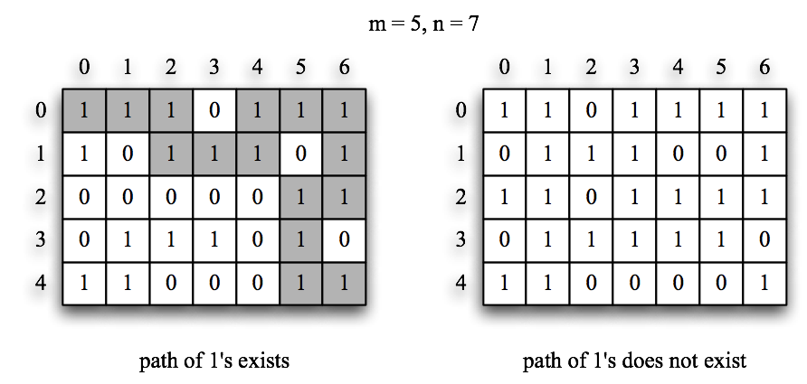

Answer:
The main problem is that the path we are tracing may branch out into two or three possible ways. For example, if we arrived at the current element from the left and there are adjacent 1’s on the top, right, and bottom, then we need to check all three directions (top, right, and bottom) for a possible path to the last element. The second problem is the danger of getting stuck in a loop as we trace our path.
There are several different solutions to the problem. One possible implementation is to use one stack to store the visited path and a list to store the visited element.
A strategy called backtracking is used in this algorithm. Backtracking strategy incrementally builds candidates to the solutions, and abandons each partial candidate as soon as it determines that c cannot possibly be completed to a valid solution. One famous implementation of backtracking can be the chess-playing computer Deep Blue developed by IBM, which has won a match against world champion Garry Kasparov in 1997.
In this problem, the starting element (data(0,0)) is firstly stored in the stack. Initially the list is empty.
Then a loop is executed in the algorithm.
In every loop, if there is a neighbor of stack peek element not inside the list, this neighbor is pushed into the stack. Otherwise, the stack will pop out the peek element into the list.
The loop ends when the peek value of stack is the destination (data(n-1,m-1)) or when the stack is empty. If the peek value is destination, the elements in the stack constitute a path from the starting point to the destination. To output the path, a second stack can be used. The first stack pop and pushes its elements one by one to the second stack. The elements in the second stack are stored in reverse order. The second stack pop and print out the elements until its empty.
If the stack is empty, it means such a path doesn’t exist.
Besides list, a 2D array can also be used to trace the visited element. The array contains m rows and n columns, all initialized to false. Every time we visit an element, we change its corresponding element in the second 2D array to true. Although this uses more space, checking if an element has been visited can be done in a single step (constant time) as opposed to searching the entire linear array in the first method.

The pseudo code of algorithm is given us follows:
Pseudocode
Pathfinder(Array[n][m] data):
Stack path
List visisted
Path.push(data[0][0])
Do until (path.peek is data[n-1][m-1] or path is empty)
if neighbor i of path.peek is not in visited:
path.push(i)
else:
visited.add(path.pop)
if path is empty:
print “such path doesn’t exist”
else:
Stack reverse_path
Do until path is empty:
reverse_path.push(path.pop)
Do until reverse_path is empty:
Print reverse_path.pop

For students who are interested in maze solving algorithms, a better known algorithm is Lee’s algorithm. Lee’s algorithm creates a new 2D array with m rows and n columns. From the starting point it sets the value of every element in the array as its distance from the starting element. Then it looks back from the destination to find the path. Lee’s algorithm can be ameliorated with distance comparison to find the shortest path between the starting point to the distination.

Below is a pseudo code for Lee’s algorithm.

Pseudocode
Lees_pathfinder(Array[n][m] data):
//initialization
Array[n][m] distance
For every element in distance:
Mark with -1
distance[0][0]=0
//wave expansion
Do:
for all neighbors of distance element marked with i:
//look for shortest path
if the neighbor is unmarked
or marked with an integer larger than i+1
mark with i+1
i=i+1
Until destination reached or all points marked
//backtrace
If destination is not reached:
Print “such path doesn’t exist”
Else:
Stack reverse_path
Reverese_path.add(destination)
Do:
Find the neighbor of path.peek with lowest mark
Reverse_path.add (neighbor)
Until path.peek is starting point
Do:
Print reverse_path.pop
Until reverse_path is empty

- The following classes are available to you. The Card class represents a single playing card, while the Deck class represents a complete deck of 52 cards.

class Card {
private String suit;
private String denomination;

public Card(String suit, String denomination) { ... }
public String getSuit() { ... }
public String getDenomination() { ... }
public void setSuit(String suit) { ... }
public void setDenomination(String denomination) { ... }
}

class Deck {
public static final int NUM_OF_CARDS = 52;

private Stack<Card> cards; // cards represent a deck of cards
// stacked face down on the table.
// In other words, cards.pop() will
// remove the top most card from the
// deck.

public Deck() { ... } // The constructor initializes the stack
// with all 52 cards, but in some
// random order.
}

  - Write an instance method public void cut(int numOfCutCards) for the Deck class that simulates cutting the deck of cards. Cutting a deck of cards is done by taking the top numOfCutCards cards from the deck, placing them on the table, then placing the remaining bottom portion of the deck on top of the numOfCutCards cards. You may not use arrays in your method. You can assume that the deck will always have 52 cards and numOfCutCards will always be less than 52. The following diagram illustrates calling cut(2) on a stack of 5 cards:

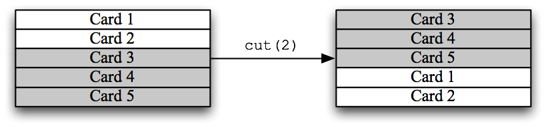

Answer:
One possible solution is to use two temporary stacks. Using the example provided in the question, we pop numOfCutCards cards (cards 1 and 2) and push them into the first temporary stack. Then the remaining cards (cards 3 to 5) are also popped and then pushed into the second temporary stack. To finish the cut, we simply put all the cards back but from the first temporary stack first. We pop the contents of the first temporary stack and push them back into our main stack. Then, we pop the contents of the second temporary stack and also push them back into our main stack.

Illustrating diagrams are on the following page.

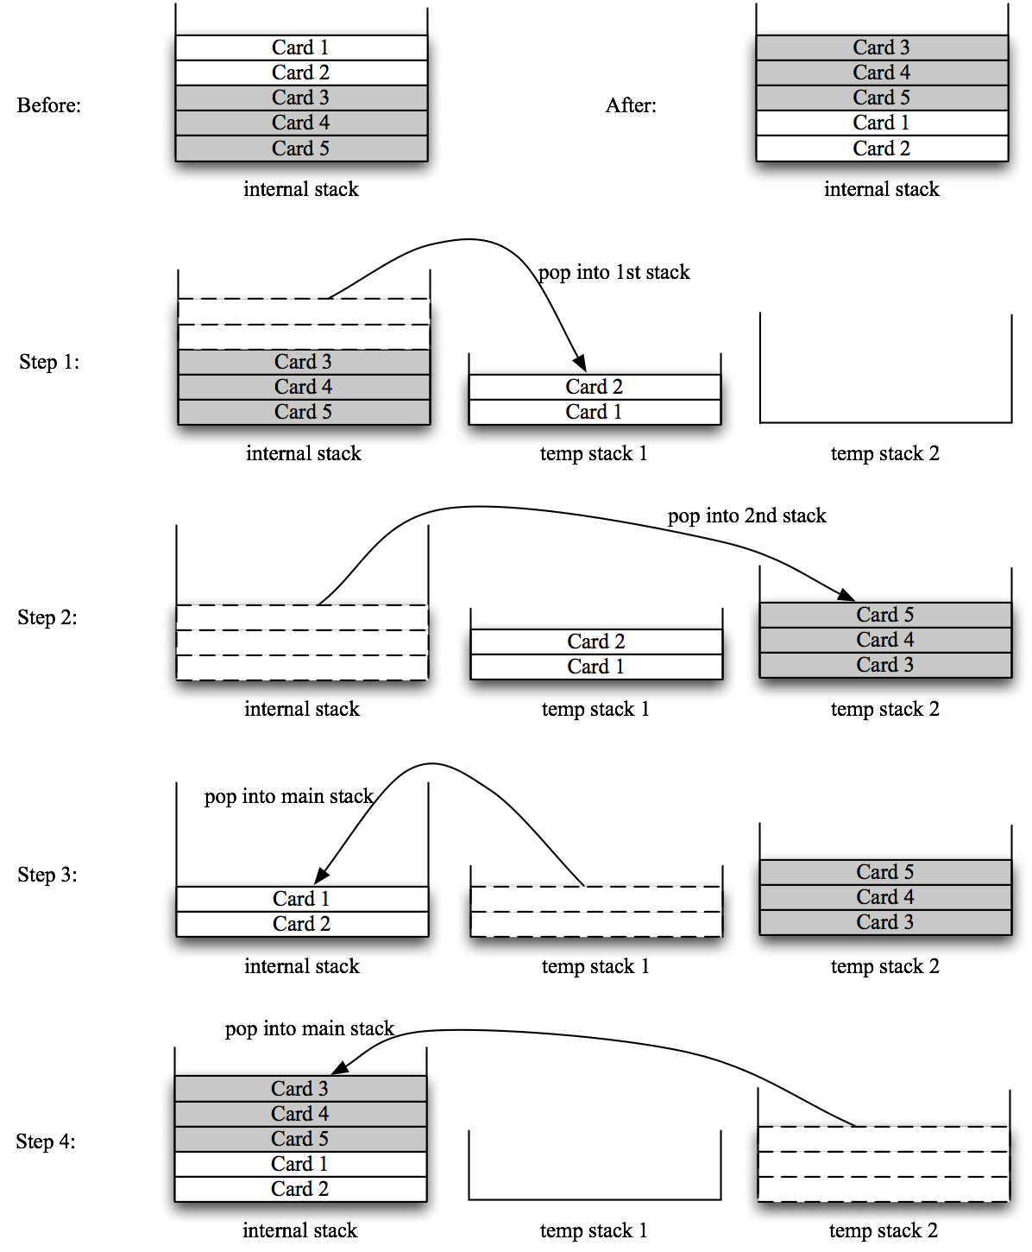

public void cut(int numOfCutCards) {
Stack<Card> stack1 = new Stack<Card>();
Stack<Card> stack2 = new Stack<Card>();

// Pop numOfCutCards cards and push them
// into the first temporary stack
while(cards.size() != NUM_OF_CARDS - numOfCutCards) {
stack1.push(cards.pop());
}

// Pop the remaining cards and push them
// into the second temporary stack
while(!cards.isEmpty()) {
stack2.push(cards.pop());
}

// Pop the cards from the first temporary stack and
// push them back into our main stack
while(!stack1.isEmpty()) {
cards.push(stack1.pop());
}

// Pop the cards from the second temporary stack and
// push them back into our main stack
while(!stack2.isEmpty()) {
cards.push(stack2.pop());
}

// Done!
}

  - Write another instance method public void shuffle(int numOfIterations) for the Deck class that simulates shuffling the deck of cards. You should assume that shuffling is done by moving a random-sized stack of cards from the bottom of the deck to the top and and repeating the process for a total of numOfIterations times. The following diagram illustrates calling shuffle(3) on a stack of 5 cards:

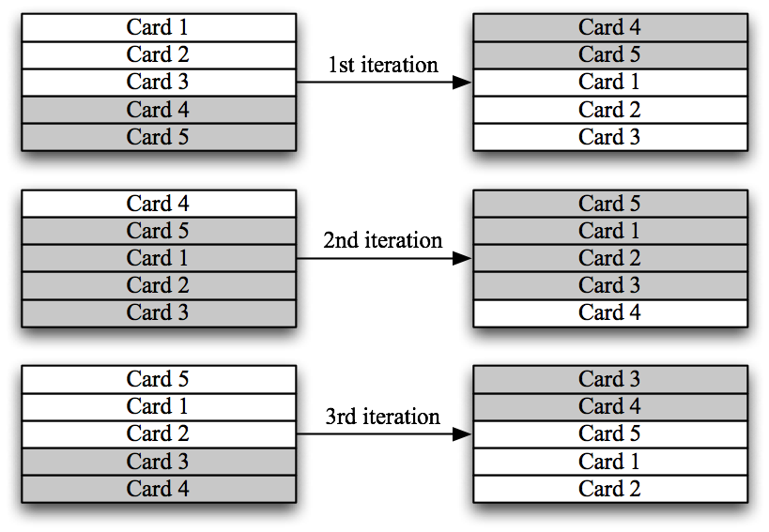

Answer:
The process of shuffling described here is actually very similar to the cutting process in (a). This is clear if we observe the diagrams provided in the question. So all we need to do is to call cut() numOfIterations times, each with a random number of numOfCutCards between 1 and 51 inclusive. This random number can be obtained by calling Math.random() which returns a double value with a positive sign, greater than or equal to 0.0 and less than 1.0. We multiple this double value with 50 (Deck.NUM_OF_CARDS – 2) and add 1, making the range of our random number between 1 and 51 inclusive.

public void shuffle(int numOfIterations) {
for(int i = 0; i < numOfIterations; ++i) {
// Get a random int from 1 to 51 inclusive
int rand = (int) Math.round(
(Deck.NUM_OF_CARDS - 2) * Math.random() + 1);

// Cut the cards
cut(rand);
}
}

  - Another way of shuffling is called the riffle or dovetail shuffle. In this shuffle, half of the deck is held in each hand with the thumbs inward, and then the thumbs release the cards so that they fall to the table interleaved (http://en.wikipedia.org/wiki/Shuffling#Riffle). Briefly explain how you would implement such a shuffle for the Deck class.

Answer:
Again, we can use two temporary stacks to simulate this shuffle. We pop half of our main stack to the first temporary stack and the remaining half to the other temporary stack. Then we start with the first temporary stack and randomly decide whether we should pop a card from that temporary stack into our main stack. The random decision can be done by calling Math.random() and assigning values greater than 0.5 as yes and otherwise no. We do the same for the second temporary stack by calling Math.random() again. This process is repeated for the first and second temporary stacks in turn until either of the temporary stacks is empty. At this point, we just pop the remaining cards and then push them into our main stack.
The code can also be written in java as follows.

public void riffle(){
Stack<Card> tempStack1 = new Stack<Card>();
Stack<Card> tempStack2 = new Stack<Card>();
s=cards.size()

while(cards.size()>s/2){
stack1.push(cards.pop());
}
while(cards.size()>=0){
stack2.push(cards.pop());
}

while(stack1.size()>=0 or stack2.size()>=0){
if(Math.random()>0.5){
stack.push(stack1.pop());
}
if(Math.random()>0.5){
stack.push(stack2.pop());
}
}
while (stack1.size()>0){
stack.push(stack1.pop());
}
while (stack2.size()>0){
stack.push(stack2.pop());
}
}

- The language Lisp, each of the four basic arithmetic operators appears before an arbitrary number of operands, which are separated by spaces. The resulting expressions are enclosed in parentheses. The operators behave as follows:
  - (+ a b c …) returns the sum of all the operands, and (+) returns 0.
  - (- a b c …) returns a-b-c-… and (-a) returns –a. The minus operator must have at least one operand.
  - (* a b c …) returns the product of all the operands, and (*) returns 1.
  - (/ a b c …) returns a/b/c/… and (/a) returns 1/a. The divide operator must have at least one operand.
You can form larger arithmetic expressions by combining these basic expression using a fully parenthesized prefix notation. For example, the following is a valid Lisp expression:
(+(-6) (*2 3 4))
The expression is evaluated successively as follows:
(+ -6 (*2 3 4) )
(+ -6 24)
18
Design and implement an algorithm that uses a stack to evaluate a legal Lisp expression composed of the four basic operators and integer values.

Answer:
In a Lisp expression, a token can be a parenthesis, a number, or an operator.
One of the solution can be designed using two stacks, one stack is used to store the tokens read from the expression one by one until the operator “)”. The other temporary stack is used to do simple Lisp calculation on the tokens pushed in from the first stack.
Tokens are pushed into the first stack one by one until it reads the first token “)” from the expression. When “)” is read, the first stack will pop its tokens one by one to the second stack until the peek value is “(”. The first stack pops out the “(“.
The temporary stack will do simple calculation on the values between the parentheses. The tokens are stored in reverse order in the temporary stack. Their order is reversed back when they are popped out from the temporary stack. The calculated result is pushed back to the first stack.
Below is an example of the algorithm with two stacks.
Expression (+(-6) (*2 3 4))
(
+
(
-
6
1. The main stack pushes the tokens one by one until it reads “)”
The main stack
The temporary stack for simple calculation
(
+
6
-
2. The main stack pops out the tokens and push them one by one to the temporary stack
The main stack
The temporary stack for simple calculation
(
+
3. The temporary stack pushes back the result after calculation
The main stack
The temporary stack for simple calculation
-6
(
+
4. The main stack continues to push in the tokens from the expression until it reads “)”
The main stack
The temporary stack for simple calculation
-6
(
*
2
3
4
Expression (+(-6) (*2 3 4))
(
+
5. The main stack pops out the tokens and push them one by one to the temporary stack
The main stack
The temporary stack for simple calculation
-6
4
3
2
*
(
+
6. The temporary stack pushes back the result after calculation.
The main stack
The temporary stack for simple calculation
-6
24
(
+
7. The main stack continues to push in the tokens from the expression until it reads “)”
The main stack
The temporary stack for simple calculation
-6
24
8. The main stack pops out the tokens and push them one by one to the temporary stack
The main stack
24
-6
+
Expression (+(-6) (*2 3 4))
The temporary stack for simple calculation
9. The temporary stack pushes back the result after calculation. When it is at the end of expression, the final result is stored in the main stack.
The main stack
The temporary stack for simple calculation
18
Assume that the expression contains no error, so the program doesn’t need to throw any exception. The pseudo-code answer can be written as follows:
Method SimpleExpressionCalculator(Stack t):
operator = t.pop()
switch operator:
case “+”:
result=0
while t is not empty:
result=result+t.pop()
return result
case “-”:
if t.size == 1:
return 1-t.pop()
else:
result=t.pop()
while t is not empty:
result=result-t.pop()
return result
case “*”:
result=1
while t is not empty:
result=result*t.pop()
return result
case “/”:
if t.size == 1:
return 1/t.pop()
else:
result=t.pop()
while t is not empty:
result=result/t.pop()
return result

Method LispCalculator (String expression):
Stack s //stack to store calculation results
Stack t //stack to store simple expression
for i in expression.nextToken:
if i equals “)”:
while s.peek() is not “(“:
t.push(s.pop)
s.pop() //remove “(“
s.push(SimpleExpressionCalculator(t))
else:
s.push(i)
return s.peek()

